================================= Spring Batch ==================================

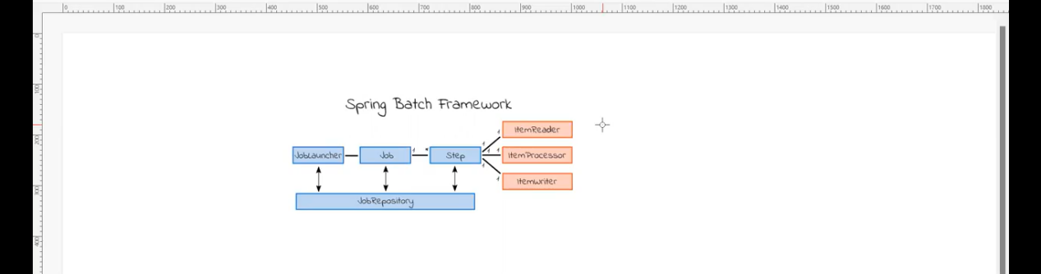

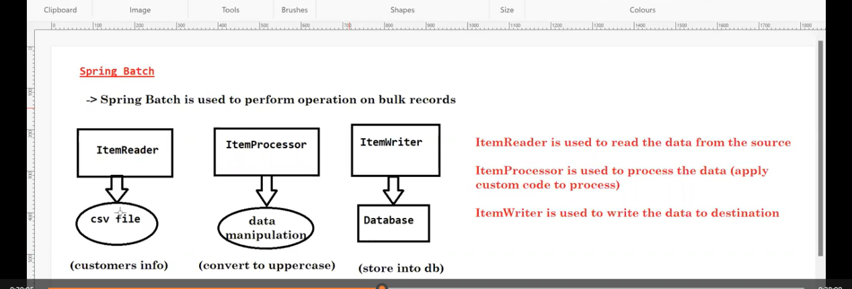

Ashok IT videos lo 76 video Spring Batch danni video loni SS ye evi yeppudu anna doubt vasthe a videos chusthe saripothundi

